Parent Handbook

Our details:

Our last day for 2021 is Friday 24th December.
We re-open for 2022 on Monday 10th January 2022.

We are open through the school holidays and close over Christmas. We are closed for all public holidays through the year.
Our hours of operation are:
Monday to Friday | 8 am till 4 pm
Preschool Session | 9 am till 3 pm
Extended Care (on request; at additional fee) | 8 am till 4 pm
Christmas and Public Holidays | Closed

Address: 384 Willarong Road, Caringbah South, 2229
Email: caringbahsouth@bigpond.com
Website: www.caringbahsouthpreschool.com
Facebook page: www.facebook.com/caringbahsouthpreschool
Instagram: @caringbahsouthpreschool
Phone number: 0414 295 269
Please feel free to call or text if you need us, either to check on your child, tell us something or advise us that your child is away.
Welcome

The Educators and Director’s at Caringbah South Preschool would like to extend a warm welcome to you and your family. We look forward to sharing many happy experiences with your child throughout the coming years.

Caringbah South Pre-School was established in 1983 as a privately-operated centre. In 2013 the centre underwent new management. Our Pre-School educators are committed to providing children with not only the best possible child care but also a quality educational pre-school program which will best prepare the children and help them to transition easily to school.

An important aim of our centre is to have good communication between families and educators both verbally and via newsletters sent by email. This helps us to provide the best quality care to meet your child’s needs in regards to care and education.

Caringbah South Preschool Philosophy
At Caringbah South Preschool we believe in providing a loving, educational and happy environment where the children come first. Caringbah South is a supportive and nurturing community, which involves the children, their families and caring educators. We are committed to providing quality education and care.
Our values and beliefs:
- We believe that all children have the right to be safe.
- We believe that all children have the right to a safe, loving, caring, nurturing, happy and diverse learning environment.
- We believe that all children are capable, creative and active learners who learn at their own pace.
- We believe that a child focused approach to planning allows children to become competent happy learners.
- We believe in creating an aesthetically pleasing, stimulating environment that allows children to grow, build relationships and gain an awareness and sense of the world they live in.
- We believe in providing a nurturing, loving atmosphere where children feel at home.
- We believe in creating a diverse, holistic and creative curriculum which allows children and families to gain a sense of belonging and respect.
- We believe in creating a positive environment among the staff, children and families to create an inclusive programme.
- We believe in positive relationships among staff, children and families and community, allowing us to develop an inclusive programme.
- We believe in collaborating with families to gain knowledge, life experiences and different cultural views
- We believe that all educators continually reflect on their practices and use ongoing training as a tool to develop and expand their knowledge.
- We believe in promoting health and hygiene throughout our centre
- We believe in implementing a quality improvement plan that allows all educators to reflect on our practices within our centre
- We are committed to the National Quality framework and to have knowledge of, understand and implement the education and care services national law and care services national regulations.
- We believe in developing our curriculum in accordance to the early year’s framework.
- We believe in liaising with early intervention services and professionals when necessary.

The Centre’s Program

The Centre’s program is planned to reflect our philosophy and goals, as well as the Early Years Learning Framework and the National Quality Framework.

Our Program Goals
- To foster positive self-concept
- To develop social skills
- To encourage children to think, reason, question, and experiment
- To encourage language development to enhance physical development and skills
- To encourage and demonstrate sound health, safety, and nutritional practices
- To encourage creative expression
- To respect cultural diversity of staff and children

Our Program
Our program includes indoor and outdoor play, in both small and large groups. We provide many experiences throughout the day, which are largely based on the children’s interests, but in a mix of child lead experiences, and teacher initiated experiences. Our program includes art & craft, construction play, sensory experiences, literacy activities, mathematic and scientific explorations and imaginative and role play. While outside, the children engage in gross motor experiences and heavy work activities, while practising their ball skills, social skills and exploring their natural environment.

Our group experiences include music and movement, language discussions, news (for the children in the Butterfly Room), interactive games and group play, while also investigating the children’s current interests.

School Readiness
School Readiness is a fundamental aspect of our program, and underpins many of the experiences provided at our pre-school. Using the EYLF as a guide, our program will see educators use intentional teaching, which is deliberate, purposeful and thoughtful in it’s delivery. Supporting all children to develop the core skills that will support them when starting school and provide positive long term impact on their learning and development.

We structure our school readiness program into 6 developmental areas, providing the children with an opportunity to learn and develop in every area that will help them become ready for school. At quiet time each day, the children will have access to a literacy based experience, a maths experience, an activity to help with pencil control, an activity to develop fine motor skills, a social experience and a technology based experience. We also provide intentional teaching moments in small groups of children in the areas of literacy and numeracy each day, to focus on a particular concept. Through out the day, we encourage the children to develop their confidence, ability to ask for help when necessary, look after and be responsible for their belongings, their independence and self help skills, and their ability to regulate their emotions.

Children’s Developmental Records
Our educators document the children’s learning throughout the year and record their observations through individual and group learning stories, work samples and records of play experiences. Each child will be provided with their own digital portfolio which will also include special interest days such as incursions or cooking, photos and the observations. At the beginning of the year, we will ask all parents to contribute to their child’s portfolio by giving us some information of interests, strengths and things to develop. During June, we will write new goals for each of the children, and there will be an end of year summary provided in November. These portfolios can be accessed at any time. If you wish to see this portfolio, just ask an educator and we will email it to you, otherwise will send them home in June and November. Our Daily Diary, which includes a slide show of photos, is uploaded to our website daily, and our weekly programs can be accessed above the Butterfly Room lockers.

Our Routines

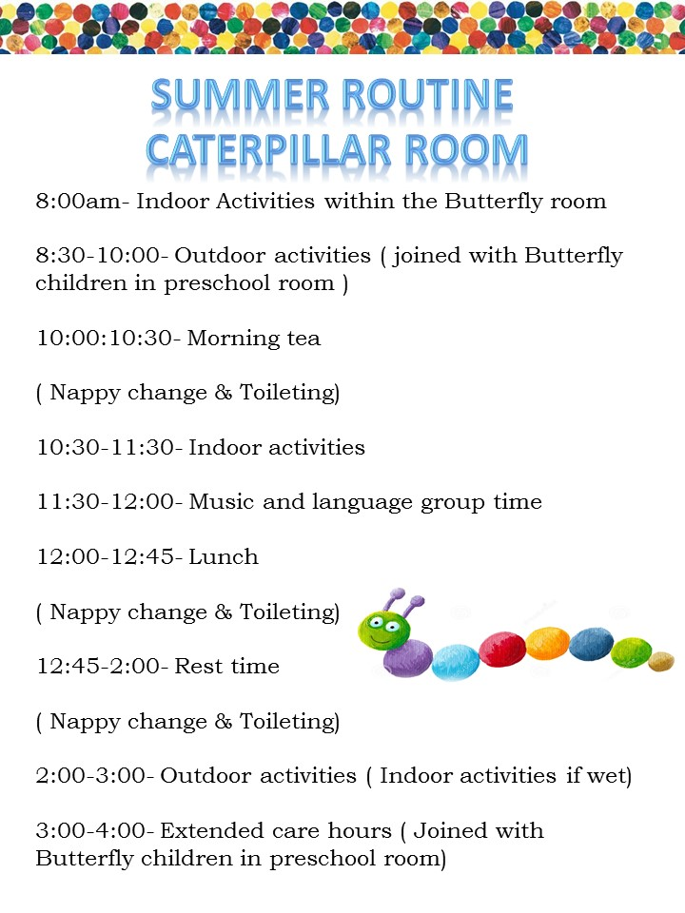

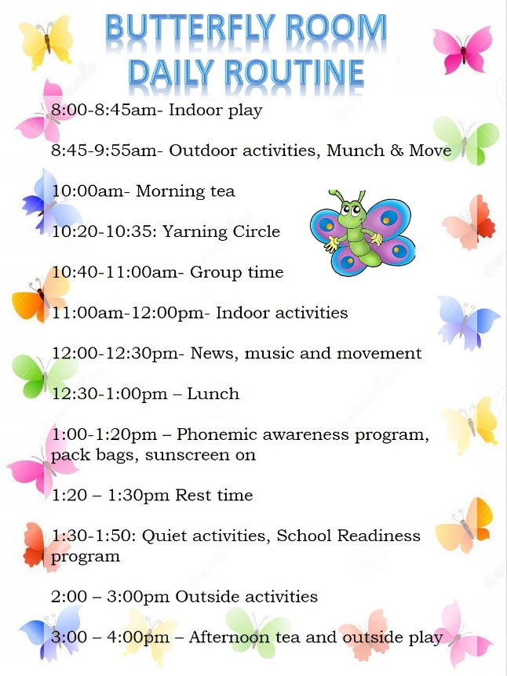
Fees

FEES PER DAY
Preschool 9am - 3pm- $78
Extended Care 8am - 4pm- $ 90
Fees are paid for the days your child is booked to attend the Centre,
including any days they are absent due to illness or personal or public holidays
Fees are payable two weeks in advance
Preferred payment is via ETF to the below bank details
Name Caringbah South Preschool
BSB - 012 262
AC- 208 066 017
Please remember to include your child’s SURNAME as the reference when making a deposit
A full 2 week deposit/bond (not including rebates) is due to secure your position at Preschool. This is a non-refundable deposit should you change your mind/circumstances change and you no longer need a place. This deposit will be added to your account on your last 2 weeks of Preschool.
Late Fees: There is a fee for families who arrive after the service closing time of 4pm. This fee is set at $50 for first 10 minutes and an additional $1 per every additional late minute as per our Fees Policy.
Commonwealth Government Childcare Subsidy
- Caringbah South Pre-School is an approved service provider.
- To claim for childcare subsidy, phone the Parent Hotline on 136150 or contact the Family Assistance Office. Families need to apply to the Family Assistance Office for a CRN number for the family and their child in care to be able to claim.
- Once you have your child’s CRN, you will then need to make a claim in order to receive the child care subsidy. This can be done either through your mygov app, centrelink app, or at a Centrelink office.
- When your child’s claim has been approved, it will then tell you what your entitlements are, and what your child care subsidy percentage is.
- When your child’s CRN and subsidy entitlements are confirmed with centrelink, it will then be processed through our system and we can apply the rebates for you. You will need to accept your child’s enrolment at the service. This can be done either through your mygov app, centrelink app, or at a Centrelink office. NO REBATES WILL BE APPLIED UNTIL THIS HAS BEEN DONE.
- All rebates are paid directly to the service, and the parent covers the gap fee which is indicated on your weekly statement. Fees are paid via EFT to the bank details mentioned above.
- Commonwealth Government Childcare Subsidy requires a medical certificate for absenteeism due to sickness. There is an allowance of 42 days absent when no certificate is needed from then full fees on absent days will be charged
- Families applying for Child Care Subsidy are required to provide evidence of their child’s immunisation status to the Family Assistance office. Families who elect not to immunise their child, will not be able to enrol in an early childhood service, unless it is for medical reasons.

Notice Period
- A 2 week notice period is required to leave the centre, reduce days or change your child’s session in terms 1, 2 and 3.
- An extended period of 6 weeks is required for term 4.
National Quality Framework (NQF) and Accreditation System

Our Preschool is assessed under the NQF. The NQF was introduced in January 2012 to set a higher benchmark for all children’s education and care service across Australia. The rating system is split into 7 categories and your overall rating is your lowest rating received in these categories. Please see our ratings below

National Quality Framework
Area 1 Educational Program and Practice | Meeting National Quality Standard
Area 2 Children’s health and safety | Meeting National Quality Standard
Area 3 Physical environment | Meeting National Quality Standard
Area 4 Staffing arrangements | Exceeding National Quality Standard
Area 5 Relationships with Children | Exceeding National Quality Standard
Area 6 Collaborative partnerships with families and communities | Meeting National Quality Standard
Area 7 Leadership and service management | Meeting National Quality Standard

Our Educators

Our Preschool is licensed by and operates under the supervision of Early Childhood Education and community’s office. We are licensed for 35 children per day.

- Colin Whitton – Approved Provider
- Carly Rigney – Nominated Supervisor, Educational Leader - Bachelor of Education (Early Childhood Education)
- Bridget Campbell – Room Leader (Diploma in Childcare)
- Taylor Kemp – Diploma in Childcare
- Tiarne Atkin – Diploma in Children’s Services
- Tayla Batcheldor – Diploma in Children’s Services
- Faith Chamberlain – Certificate III Children’s Services
- Alison Hutchinson – Certificate III in Children’s Services
- Tia Tuerlings – Certificate III in Children’s Services, studying Diploma
- Leza Eckford – Certificate III in Children’s Services – regular casual and support worker
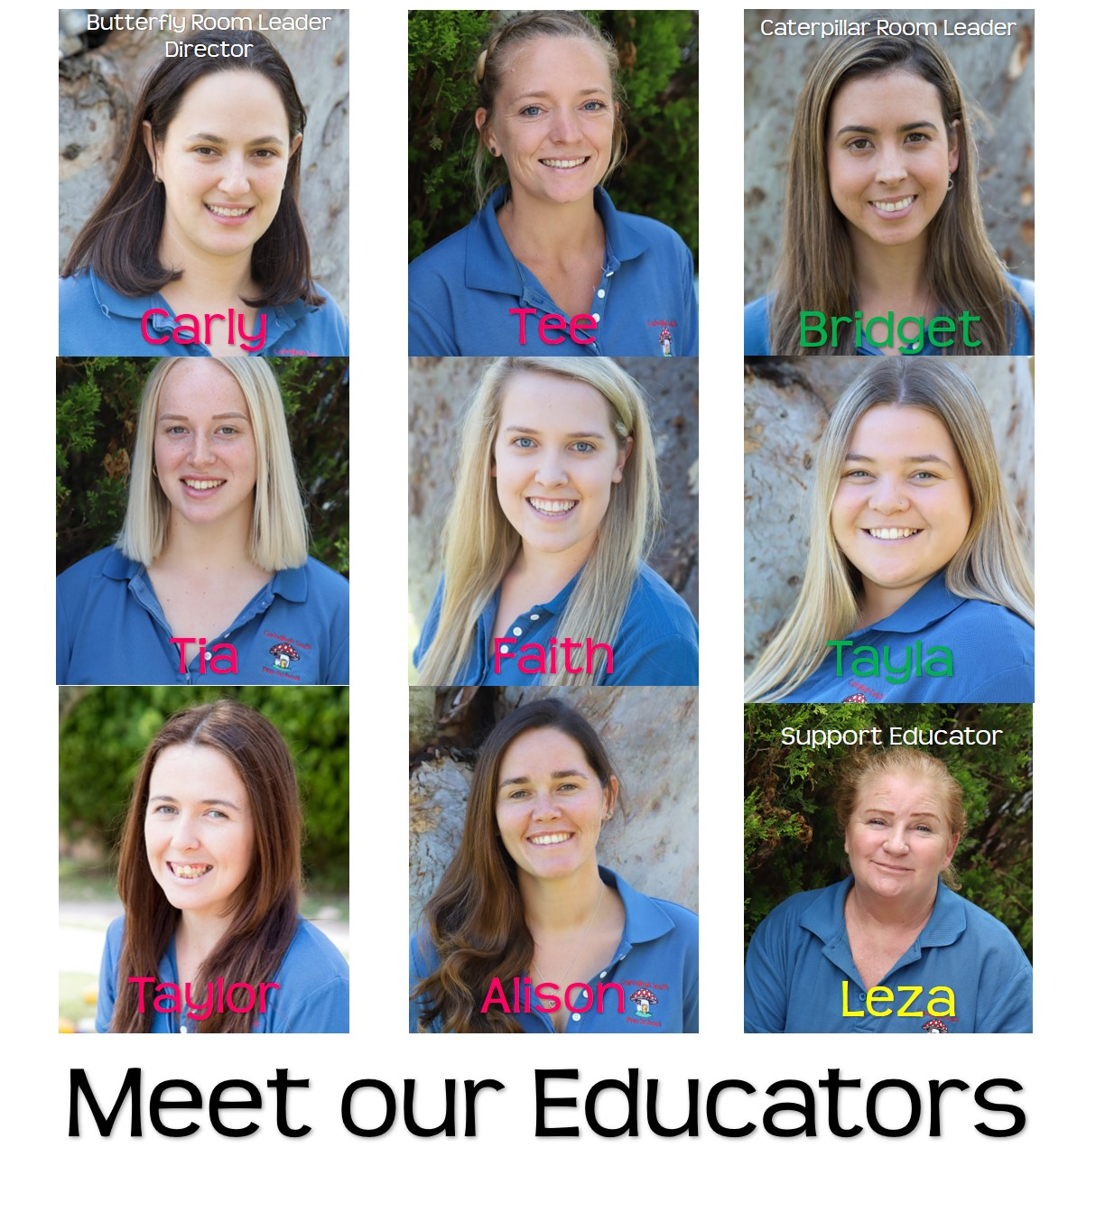

Website

We take photos of the day’s activities and publish a daily diary daily onto our website for you to view in your own time. www.caringbahsouthpreschool.com . There is a password that you will need to access the “Parent Portal” on our website, which you will be given upon enrolment.
We also use our facebook page to post photos of special events, daily activities and reminders for events coming up! Please follow us so that you can keep up to date with everything we are doing!
https://www.facebook.com/caringbahsouthpreschool/

Newsletters / Communication
Newsletters are emailed every month with the upcoming dates for the current month, and for the following month. Please be sure to read all newsletters as they contain important information, changes and upcoming events. The noticeboard outside will have reminders for upcoming events, as well as through our facebook page. Please ensure that you notify the preschool of any changes to your email address or if you are not receiving the newsletter or other emails. If you have any feedback from the newsletter or in general, please email us directly at caringbahsouth@bigpond.com

Parent Involvement

Parents are always welcome to visit the centre at any time. We ask parents to supervise siblings closely as often there are activities in progress.
We value parent participation in the development of the centre’s curriculum. Educators regularly consult parents, for example:

- at enrolment
- informally daily
- through newsletters
- the centre’s notice board

Families are invited to contribute to our program by:
- Informing educators of their child's interests, or special events in their child's life.
- Informing educators if they have concerns about their child's development.
- Participating in our special guests program in which parents with special talents or occupations are invited to share and interact with the children.
- Providing resources such as books, artefacts, photos, and videos, to enrich children's learning experiences.
- Providing craft materials, such as boxes, paper etc.
- Participating in our activities program, where parents can help children with activities such as sewing and cooking.
- Assisting at special events, such as excursions and parties.
- Providing feedback to assist in evaluating our programs.
- Attending Parent / Teacher interviews
- Once a year a qualitative survey is carried out to assess parent/children satisfaction levels in service and programs.
- Educators will provide opportunities / or arrange meetings for parents to help the centre make and review policies; to help in decision and or offer advice on fund raising activities; programming, entertainment, and so on.
- The centre and educators will communicate with all families including families from culturally diverse and linguistically diverse backgrounds by various means Eg. face to face, meeting, noticeboards, posters, photo displays, videos, open days etc

Things your child needs to bring to Pre-school

All children are allocated a locker at the centre where their belongings are stored. Please ensure all your children’s belongings are clearly labelled with his or her name. In the Caterpillar Room, the children will have an allocated locker (see the chart above the lockers) and in the Butterfly Room, the children choose their own locker daily.

Clothing
- Dress for preschool should be casual and comfortable.
- Take into consideration the child’s ability to cope with toilet needs
- A full change of clothing is required to keep in your child’s backpack, in case of accidents (toileting accidents, water play or accidently getting too dirty!)
- A warm jacket (in winter) and clothes that provide sun protection in summer
- A wide brimmed sun hat is required for outdoor play

Nappies (if your child is not toilet trained)
- Nappies (a box or packet to keep here is fine)
- Nappy cream if needed
- Wipes if you prefer your own

Shoes
- Label shoes clearly with child’s name. Shoes should preferably not include laces, as we encourage the children to put these on themselves.

Food
- NO NUT PRODUCTS ARE PERMITTED – WE ARE A NUT FREE CENTRE
- Children need food and drink to cover morning tea, lunch, and afternoon tea for Extended Care
- Please provide nutritious food for lunch as well as snacks, eg fruit, yoghurt, cheese and biscuits.
- No lollies, chips, or chocolate. These will be sent home in your child’s lunch box to be consumed at home.
- Pack morning tea and lunch in separate containers, morning tea and afternoon tea are placed in the designated baskets
- The children’s lunch boxes will remain in their bags within their locker so you may wish to pack an ice brick.
- Please bring a drink bottle and place it on the tray at the front of Preschool. WATER ONLY
.
Rest Time
For the children in the Caterpillar Room rest time occurs after lunch, At the start of term please provide
- One fitted cot sheet and top sheet
- Label sheets with your child’s name
- Warm blanket for the cooler months
- Labelled bag to contain rest items

Comfort Items
Send along any security items, particularly those required at rest times-teddy, dummy etc

Reusable Wet Bags
We would appreciate keeping a reusable ‘wet bag’ in your child’s bag to send wet clothes home in. This will help us to be sustainable and limit the amount of one use plastic bags that we use.
These can be purchased on the internet, or even on ebay or aliexpress/wish etc for very reasonable prices as low as $4! Please ensure your child’s name is on it.

School Bag
- Ensure the bag is large enough to fit all of your child’s belongings
- Label bag with your child’s name on the outside
- Ensure your child can undo the bag

Special Events

Excursions
We ask for parental involvement during excursions to provide a high level of safety.

Special Guests
Our activity calendar includes special visitors to the centre, such as musicians, fire officers, fire trucks, and police officers.

Birthdays
Children always love to celebrate their birthday with their friends. It is a good idea to send along a birthday cake to make it a special day for your child. Although individual portions (cupcakes) are preferred, please ensure that either alternative allows for 27 portions for the Butterfly Room and 10 children in the Caterpillar Room. Our preschool will provide candles, a special happy birthday hat for the child, and we will all sing happy birthday together. This is a very special moment that all children love to participate in.

Celebrations
We celebrate many dates of significance to our community, families and the world around us. These include but are not limited to Harmony Day, Christmas, Easter, NAIDOC week, Australia Day, ANZAC day, Mothers Day, Fathers Day, and Grandparents Day. We also take part in educational events including Book Week and Science Week, and recreational events such as International Pancake Day, Pirate Day, and Pyjama Week!

In recent years, the preschool has also been proud to play a role in raising money for charities such as the Asthma Foundation, Sydney Children’s Hospital and the Kookaburra Kids Foundation. This provides opportunities for children’s learning and is a wonderful way to participate in the community.

Parent Date Night
Once every few months, we offer a parent date night, where the educators will look after the children at the preschool on a Saturday night to encourage the parents to go out and enjoy themselves, child free! Spaces are limited and there is $50 per child cost, which will go towards paying the educators for their time and food for the children, with any left overs going towards funding some exciting shows and incursions for the children during the year. These have been fantastic nights where the children have had so much fun engaging in a movie night or disco, while the parents have enjoyed themselves too!

Settling In

Starting preschool for the first time or even starting at a new preschool can be a very emotional time for both children and parents. Each child will take a different length of time to settle into preschool. While some children settle immediately, others may take a little longer and may have difficulty separating from their parents, this is completely normal and appropriate for newcomers.
Before your child starts at our service, we encourage families to bring their child to visit and become familiar with the centre and our educators.
We understand how distressing it can be for parents whose children become upset when they leave. Although we are happy for you to spend time with your child at preschool in the morning, we do ask that you always tell your child you will be back in the afternoon, say goodbye and make a prompt exit rather than lingering to console them (as this only distresses the child more when you eventually leave). If you are concerned, feel free to call the centre during the day to see if your child has settled. We want preschool to be a positive experience for your child and we will do anything we can to keep your children happy.

Notifying the Centre of Absence, Illness, and Changes

Staff should be advised if:
- Your child will be away on holidays or is sick
- Custody or access arrangements have changed
- Work, home address or phone numbers have changed
- Any conditions that may affect the well being of your child, eg, sleepless night or a parent away

Sign in and Sign Out
- A tablet is used for an electronic sign in system, located by the front door of the pre-school.
- This must be signed each day when arriving and departing and the actual times noted.
- In the event of an emergency (such as a fire) the tablet is the record staff use to determine the children in the building at the time and each child must be accounted for.
- Please notify staff if a different person is to collect your child from the Centre. The person will need to show their ID to a staff member when they arrive.

Authority to Collect Children

- Only persons authorised under prior arrangement and noted on the Authority to collect form will be allowed to collect your child.
- In an emergency parent, may contact the centre by phone to notify of alternative arrangement.

Child Protection Policies

Child Protection-It is mandatory for child care centre staff to notify suspected abuse and neglect of children to the Department of Community Services. All staff are aware of issues relating to child protection. The centre has a Child Protection Policy that identifies the types of abuse, indicators and staff’s responsibilities for the rights of the children.

Emergency Evacuation, Fire Drill and Lock down

During the first term, we teach the children the fire drill and lock down procedure, we then practice these once a term.

In the event of emergency or fire, children will evacuate the centre in a calm and orderly manner. In the event of a centre lock down children will be taken into the caterpillar room until the threat has been dealt with. Parents will be notified to collect their children if necessary.

Health Policies

Medication

If your child requires medication complete a “Medications” Form and give the medication to the teacher.

All medication must be in the original container, with the label showing the doctors name; date of issue; instructions; and the time.

No medication can be given if the Medications Form is not completed.

Antibiotics

If your child is sick enough to be taking antibiotics for a contagious infection he or she should be kept at home at least for the first day of the course.

The centre is not a place for a sick child.

High Temperatures

If your child has a high temperature of 38 and above, please do not send them to Preschool as this means your child has an infection (If your child is sent home with a high temperature of 38 and above there is a 24hr exclusion period). Please notify staff if your child has recently been unwell or not in their normal state of health, or if their siblings have been unwell.

Infectious Disease, Immunisation and Exclusion

Please notify the Centre if your child is absent with an infectious disease - for the safety of other children, staff and pregnant visitors. The centre abides by the exclusion time recommended by the Department of Health.

If there is an outbreak of an infectious disease the centre will notify the Health department and follow the directions. Parents would also be informed. If a child is unimmunised or has incomplete immunisation and there is an outbreak of a disease, then that child will be excluded from the centre as directed by the Health Department for a specified time.

On enrolment parents, must show proof of immunisation of their child. This must be from Medicare and can be emailed directly to us from the Medicare app. It must be the “Immunisation History Statement” that shows that the immunisations are “up to date.”

Allergies and Medical Conditions

It is essential that the Centre is made aware of any allergy or medical condition (whether short or long term) that your child may have, such as bee stings, epilepsy, and asthma.

Information regarding allergies and medical conditions is to be included on the enrolment form.

This is a parent (or guardian) responsibility and needs to be updated regularly.

If you would like more information on our Health policies, please see the Centre’s staff.

Incidents and Accidents

All educators at Caringbah South Preschool hold a current First Aid Certificate. While every effort is taken to avoid accidents, they may occasionally occur.
In the case of an accident or illness that requires immediate medical aid, staff will attempt to contact parents (or the emergency contact) by phone and seek medical assistance if necessary.

When collecting a child, staff will inform the parent (or guardian) of any incident that occurred during the day. Staff will also complete an Incident Report form and a copy will be given to the parent if they request one when they arrive at the Centre. The parent (or guardian) is responsible for all costs incurred (doctor, ambulance, hospital etc).

Sun Protection

To assist in protecting your child from the sun,

Apply sunscreen to your child, before arriving at the centre

Provide a hat - with a wide brim or with a neck flap
- We suggest that all children have a shirt that covers their arms whilst in the sun

We will re-apply sunscreen to your child during the afternoon, when playing outdoors

Management of Unwell Children
It is the centre’s aim to maintain a healthy environment for all children and staff.
Parents will be notified to collect children if:
- children are unwell and unable to participate in normal activities
- have a high temperature- children are to remain home for 24 hours after last high temp
- vomiting - children are to remain home for 24 hours after last vomit
- diarrhoea - children are to remain home 24 hours after last diarrhoea
- ear ache
- sore throat
- asthma
- bad coughing
- head lice
- mucous discharge (green mucous indicates infection)
- infectious disease- such as conjunctivitis, covid-19

Nutritional Policies

Nutrition in childhood influences growth, activity, and intellectual and emotional development. We ask that parents provide healthy and nutritious food for their children. During meal times the staff will discuss the nutritional value of food. If parents would like some advice on nutrition please see the educators. Please do not send lollies, chips, and chocolates. Only water is to be provided in the children’s drink bottles.
Uneaten food that is perishable will be thrown out (due to safe food handling practises), other food is sent home in your child’s lunch box so parents know what their child has eaten during the day.

Nut Allergy
Nuts and nut products are banned at the centre as some children have severe allergies. Thank you for your cooperation as this allows all children to enjoy preschool.

Grievance Policy – Concerns and Complaints

We believe that discussing issues and resolving concerns and complaints help us provide a better service for the children and their families.

If you have any concerns or complaints, please make them known either to the centre’s staff or director.

You may express your concerns or complaints:
- informally – by approaching staff
- formally – by filling out a Complaint Form, or
- anonymously – by letter
We can then make every effort to resolve your complaint quickly and respond accordingly.

Safety and Emergency Procedures

Emergency evacuation procedures are displayed in the room and throughout the centre. Our staff are trained to deal with the such emergencies and at regular intervals emergency evacuation drills are practiced with the children., The staff at the centre have first aid training and are equipped to handle emergency First Aid situations.

Enrolment Patterns

At Caringbah South Pre-school, we require all children to attend the service for a minimum of 2 days, we do not currently accept 1 day enrolments unless that is all we can offer you. This is because we strongly believe that for children to be part of the room, engaged in the program and able to develop friendships, they need to be attending enough to immerse themselves within it. This also helps with their transition to pre-school, ability to form strong bonds with educators, and also keeps the flow of our room running smoothly.

Interpreting Services for Non-English speaking families
Ethnic Affairs Commission of NSW offer interpreting and translating services
Toll free 1300 651 500
Web site www.eacnsw.com.au/interpreting.

Centre Policies

All the centre polices are written in detail in the Parent Policy Folder which is located at the sign in desk for you to access. Please let the staff know if you would like an electronic copy of any of the policies emailed to you. Thank you for taking the time to read this booklet. We hope it has been both informative and interesting.

